MACH4METAL

metalworking machinery
Transito 21,
6909 DA BABBERICH, Netherlands
Tel. + 31 (0)316 – 247123
Fax. + 31 (0)316 - 247956
info@mach4metal.com
www.mach4metal.com

Bank No : 66.52.13.883
IBAN : NL33 INGB 0665 2138 83
BIC : INGBNL2A

SAHINLER hydraulic workshop press
straightening with moving piston 80 T
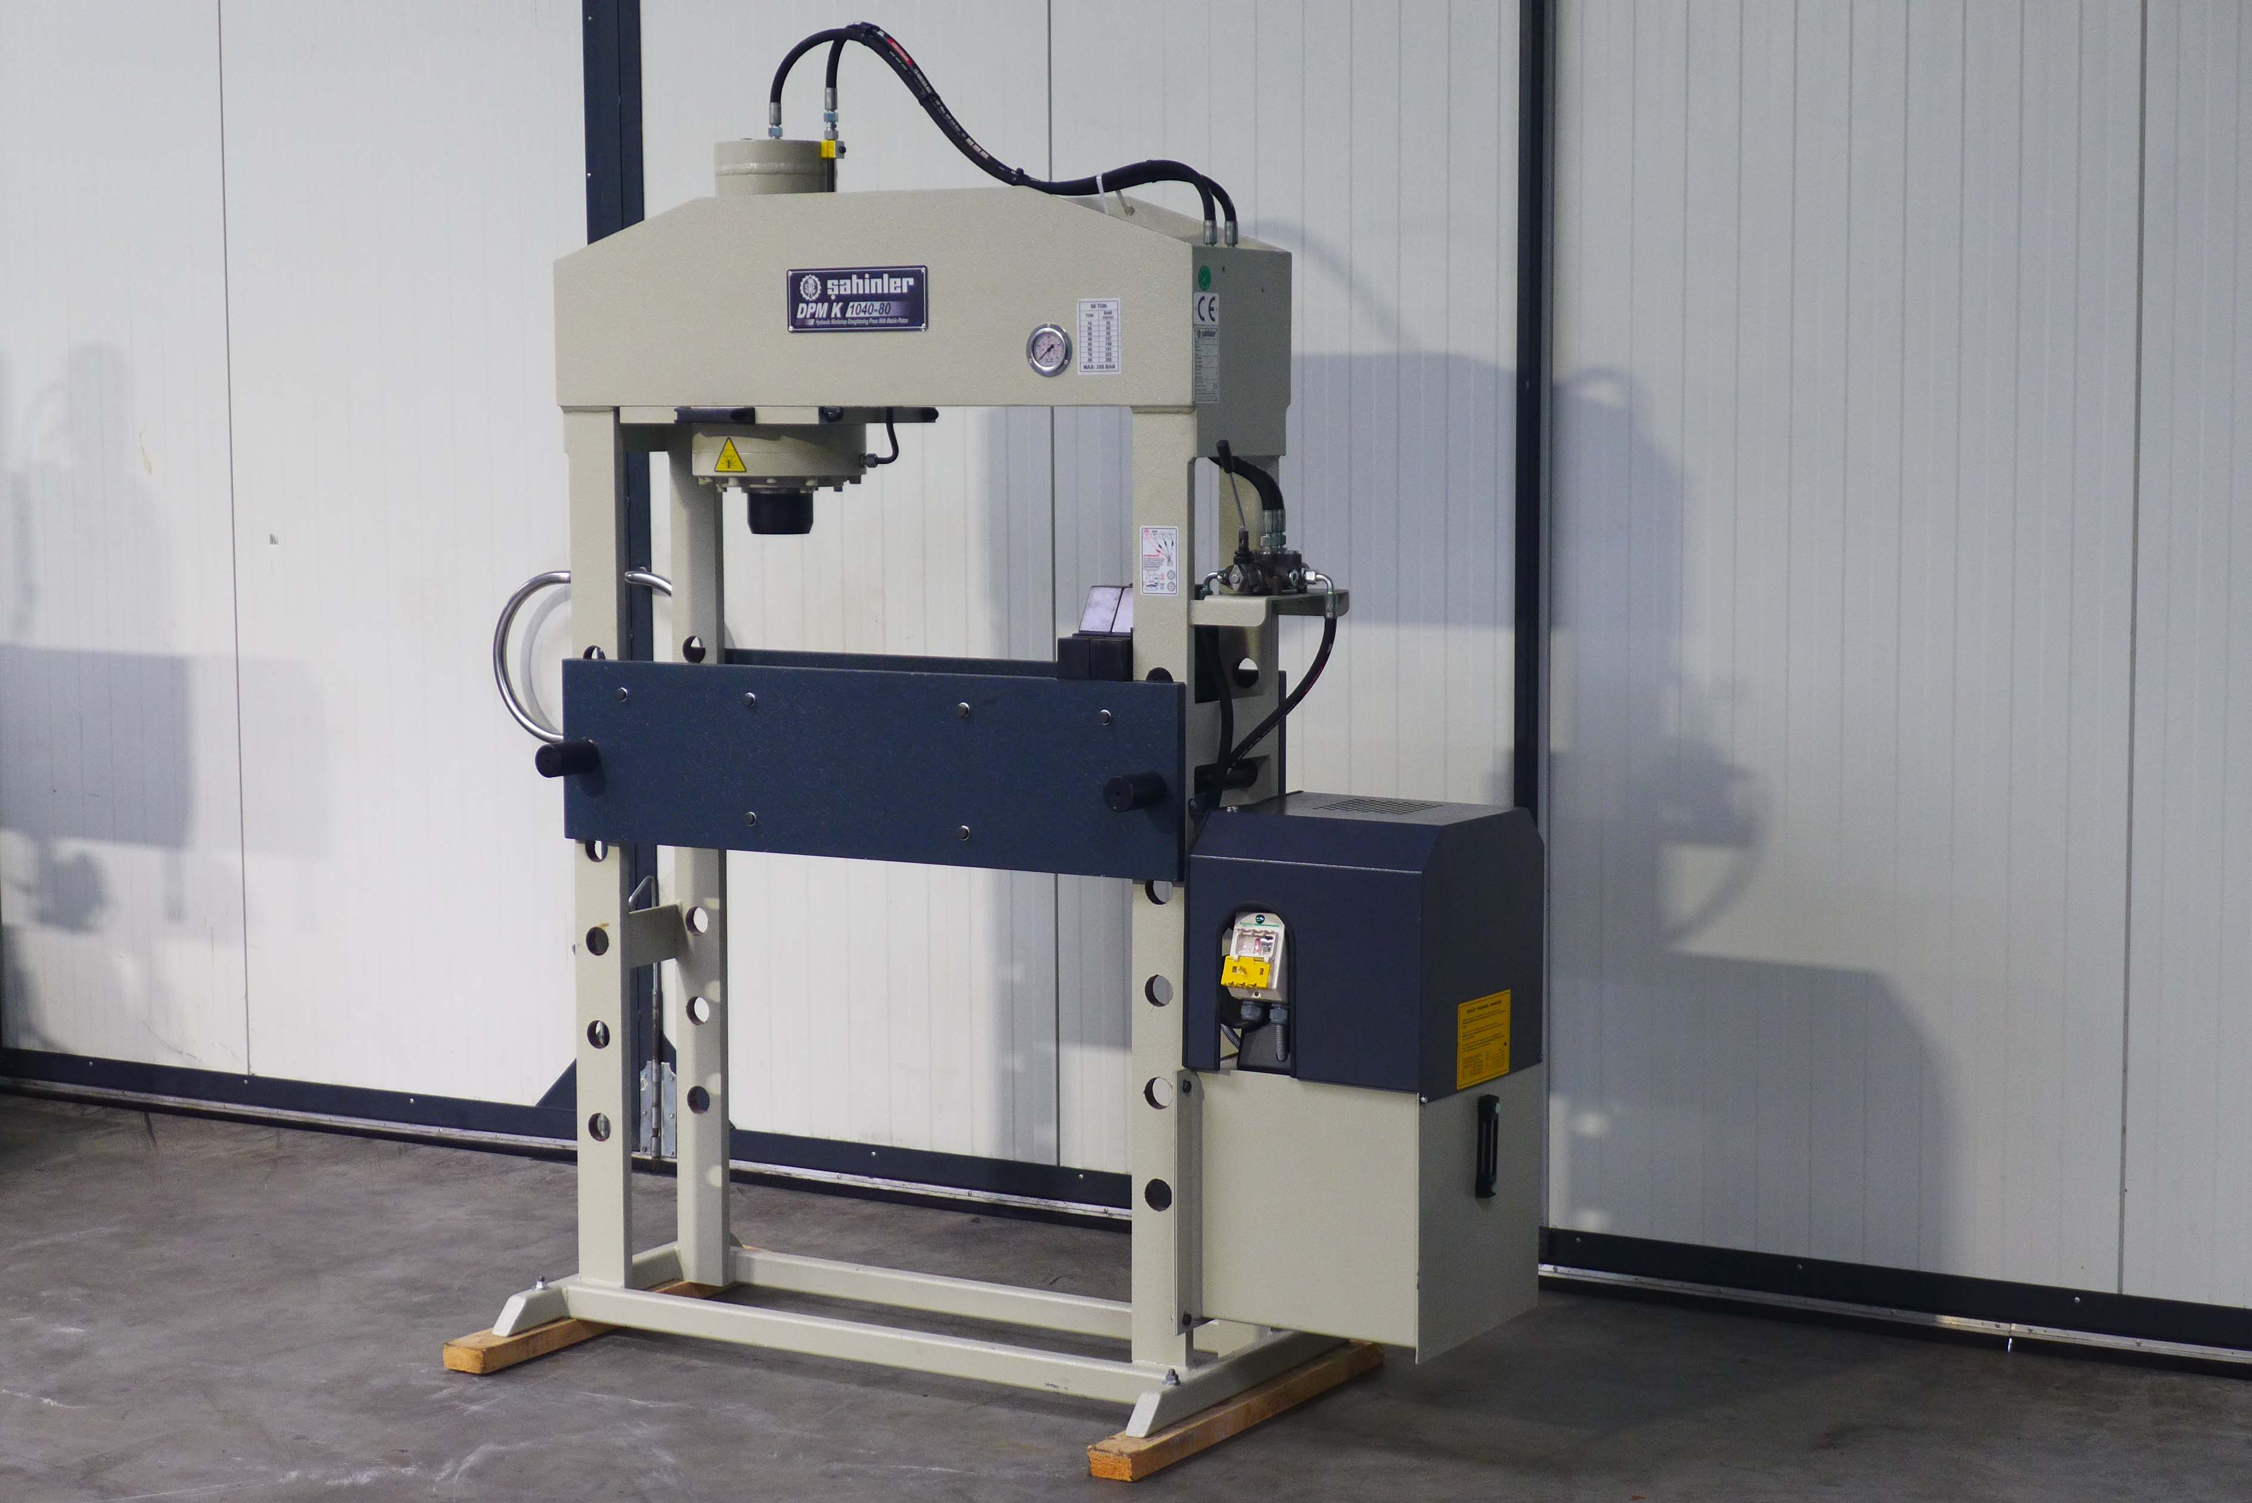
- Make : Sahinler
- Typ : DPM K 1040 80
- Serial No :
- Age : 2014

- Pressing force : 80 T
- Distance column E :
- Stroke : 250

- Min. Distance table piston K :
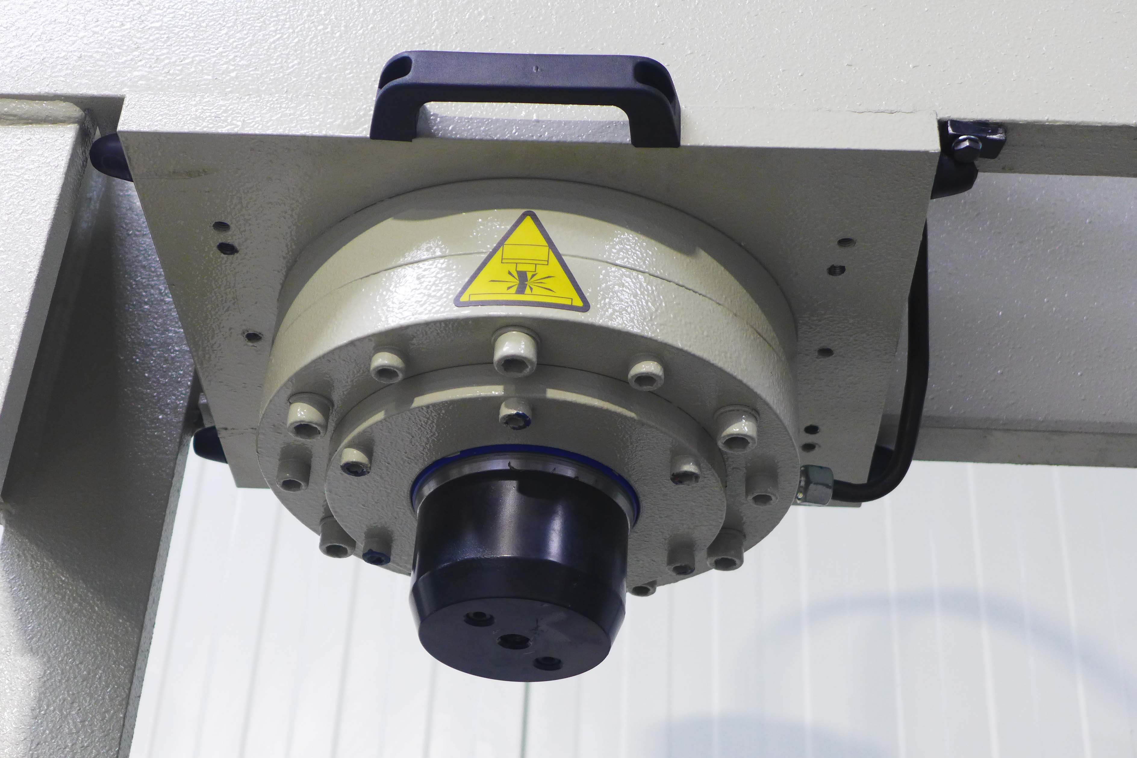
- Max. Distance table piston K :

- Bore diameter in column D :
- Jump bore to bore P :
- Max. height table O :
- Diameter piston : 200 x 120

- Approach speed : 8 mm/sec
- Working speed : 5 mm/sec
- Return speed : 10 mm/sec
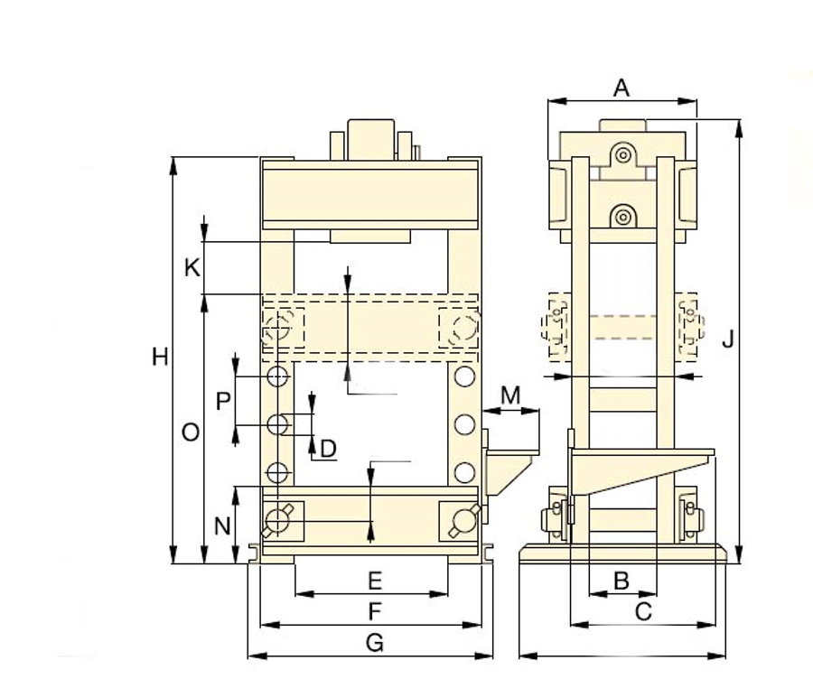

- Dimensions
- Length G : 1.810
- Width A : 750
- Height J : 2.100
- Weight : 835
- Power : 5.5 kW

- Stop at any position
- Set off unused V-Blocks
- Adjustable table height
- Control over joystick

Please Note: The above information has been obtained to the best of our ability and belief from, and from the manufacturers where possible. It is given in good faith, but its accuracy can not be guaranteed. Accordingly, it will not form a representation or constitute contractual terms. We advise you to check any vital details!

